Mathematics Methods Investigations

Year 12

Topic 4.3: Interval estimates of proportion

Authors: Rom Cirillo
Margaret Denham
Jo Giumelli
James Heseltine

Editors: Rom Cirillo
Ann Shugg

For each topic three types of tasks are included:
Extended investigation – an investigation which could be done in the student’s own time followed by an in-class validation. Solutions are provided where practicable for the preparation activity/investigation. For the in-class validation, there are solutions and marking keys which identify the mathematical behaviours that students may exhibit.
In-class investigation – an investigation for which no prior preparation is required. Solutions and marking keys are provided.
Investigative questions – a series of short questions which test the student’s ability to apply their learning, to justify their conclusions, to investigate and to generalise, or to solve problems. Such questions could be included in a response or examination assessment. Solutions and marking key are provided.

Screen shot have been produced using the CASIO ClassPad II emulator or the ti-nspire CAS emulator.

Most graphs and diagrams have been produced using efofex software.

© The investigations and solutions in this publication are for the sole use of staff and students of the purchasing school. It is a breach of copyright to distribute them in whole or part in any form now or in the future to any other school, company or person.

Contents:
MATHEMATICS METHODS: Year 12
3.1 Further differentiation and applications
Task 1: Extended investigation: The second derivative
Task 2: In-class investigation: Taylor series
Task 3: Investigative questions

3.2 Integrals
Task 4: Extended investigation: Area between functions
Task 5: In-class investigation: Areas between graphs and the x-axis
Task 6: Investigative questions

3.3 Discrete random variables
Task7: Extended investigation: Distribution of sample means
Task 8: In-class investigation: Binomial distribution
Task 9: Investigative questions

4.1 The logarithmic function
Task10: Extended investigation: Logarithms
Task 11: In-class investigation: The logarithm function
Task 12: Investigative questions

4.2 Continuous random variables and the normal distribution
Task13: Extended investigation: The Normal distribution curve
Task 14: In-class investigation: Continuous distribution curves
Task 15: Investigative questions

4.3 Interval estimates for proportions
Task16: Extended investigation: Simulating population distributions
Task 17: In-class investigation: Interval estimates
Task 18: Investigative questions

This package only contains the investigations associated with topic 4.3: Interval estimates for proportions.

If your school has purchased the complete set of 18 investigations, this is the last in the set.

TASK 16: SIMULATING SAMPLE DISTRIBUTIONS

Extended Investigation

Unit 4

Topic 4.3: Interval estimates for proportions

Course-related information

The concepts and skills included in this investigation relate to the following dot points within the WA Mathematics Methods syllabus.

Random sampling
4.3.3 use graphical displays of simulated data to investigate the variability of random samples from various distributions, including uniform, normal and Bernoulli.
Sample proportions
4.3.4 examine the concept of the sample proportion $\hat{p}$ as a random variable whose value varies between samples, and the formulas for the mean $p$ and standard deviation $\sqrt{\frac{p\left(1-p\right)}{n}}$ of the sample proportion $\hat{p}$
    - examine the approximate normality of the distribution of $\hat{p}$ for large samples
4.3.6 simulate repeated random sampling, for a variety of values of $p$ and a range of sample sizes, to illustrate the distribution of $\hat{p}$and the approximate standard normality of $\frac{\hat{p} –p}{\sqrt{\frac{\hat{p}\left(1-\hat{p}\right)}{n}}}$ where the closeness of the approximation depends on both $n$ and $p$

The ability to choose and use appropriate technology to enhance and extend concept development are also incorporated within some of the items.

Background information

Students should have completed the study of the topic, continuous random variables and the normal distribution, and have some understanding of random sampling.
Competence with a CAS calculator is assumed.

Task conditions
Students have a take home section of the investigation that they can work on for several days. If the learning program permits, providing significant class time for students to familiarise themselves with the task is recommended, especially for those students that may need to improve their CAS calculator skills to perform the required simulations.
The aim of the preparation activity is to give students a ‘feel’ for the use of digital simulations – so that they are not so much ‘black box’ activities.
In so far as the preparation activity covers the key concepts related to sample proportions, this task may be used to substitute a significant portion of in-class learning on the topic. Students then have an in-class assessment on the content of the investigation.

Students should not be permitted to take their investigative material into the class test.
It is essential that students bring their CAS calculator to the in-class validation.

Simulating sample proportions and their respective distributions

Extended Investigation Part 1: Preparation activity

Background context

In recent years there has been an increasing community awareness of the need to conserve water, especially regarding the wise use of water on gardens.
The WA Water-Wise Gardening Company (WWGC) which provides gardening mulch to households throughout WA, has been steadily expanding its client base within WA. The company executives are trying to decide whether to expand the mulch providing services, Australia wide.
They know (by sourcing data from the last ABS census) that 52.2% of WA households apply mulch to their gardens as a way of reducing water use, but Australia wide, only 42.6% of households apply mulch to their gardens.

They employ a researcher to help them make the decision.

The researcher conducts a survey on a random sample of 100 households throughout WA and finds that, over the past 12 months, 25 of the 100 households used mulch from WWGC.

In order to contain costs, she performs digital simulations to produce relevant data and graphs to help in make decisions.

Understanding digital simulation of random samples
For the purpose of this exercise, we will limit the digital processes to some of the ones available on a CAS calculator
On the ClassPad the rand() command in main will produce something like the following.
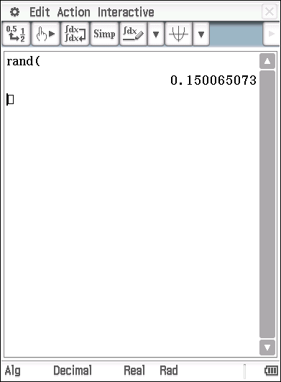
That is, it will produce a random number between 0 and 1.
How may we use this to simulate the likely responses of say, a sample of 10 households, as to whether they used WWGC mulch or not?
Firstly, we would like to record a 1 if they used WWGC mulch and a 0 if they did not.
If we take a randomly generated number between 0 and 1 and add 0.25, then the integer value of the resulting number will be 0 or 1, with a 1 representing a household that used WWGC mulch, (based on an underlying distribution from which 25% of households used WWGC mulch). Let’s try it a few times and see what happens.

Firstly, type in the following statements in ‘main’
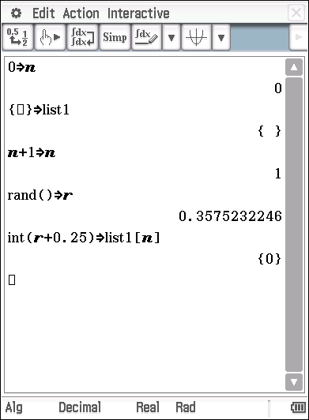
The first statement sets the variable to 0.
The second statement clears list1 in the statistics app.
The next line is a counter, so we know how many times we have generated a random number.
Next we generate a random number (between 0 and 1) and store it in

The last line takes the integer value of the random number with 0.25 added to it, and stores it in list1.

A few points to note before we proceed any further.
- Save your program
- If at any time, you want to clear the list of data and start again, place the cursor in the very first line and hit enter.
- To generate a second random number (simulating asking a second household in they used WWGC mulch) place the cursor in the third line and hit enter.
- Repeat this process a few times and watch what happens.
Below is a screen capture of the result after repeating the process 6 times. In this particular example of the simulation, it took 6 attempts (or ‘trials’) before a high enough random number was generated (0.9827956809) so that a ‘success’ could be recorded. (A success being interpreted as a particular household having used WWGC mulch in the last 12 months.)
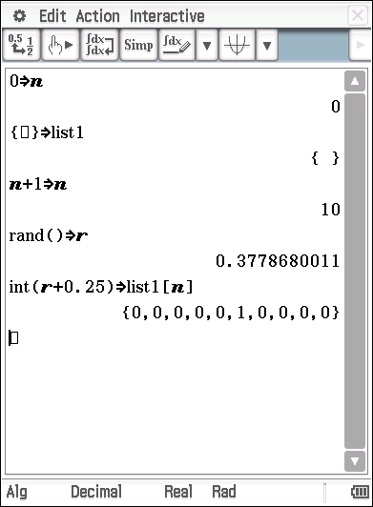
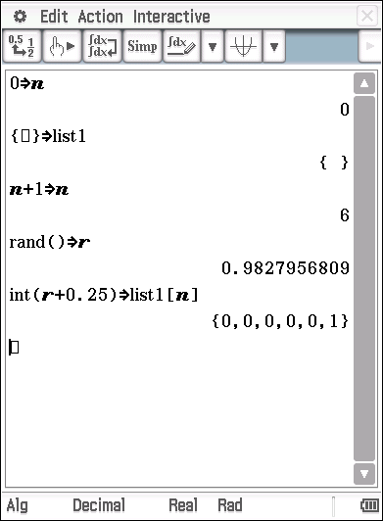
The second screen shot shows the result of simulating a random sample of 10 households.
As you can see, in this randomly generated sample only one of the households used WWGC mulch.
Try a few simulations of samples of size 10 for yourself. Remember, to start the generation of a new sample, place the cursor in line 1 of the routine and press execute. For the subsequent 9 simulated trials, place the cursor on the third line (ie. on the n+1⇒n line) of the routine and press execute each time.
Below is an example of such a simulated sample of 10 trials (ie. households)
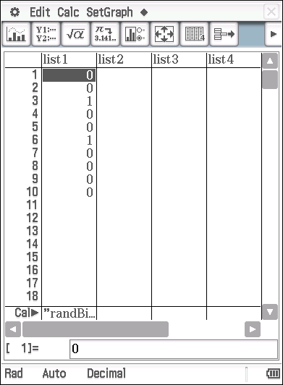
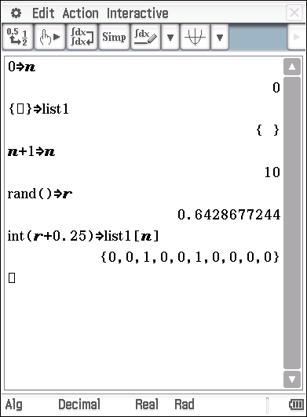
The second screen shot shows the generated numbers stored in list1 of the Statistics App.
Check this out on your own calculator.
Task 1
Write a brief statement of interpretation of the information list1, in terms of the context of the situation.

Let us now increase the sample size to 15 households and re-perform the simulation.

Before doing so, let us add an extra line to the routine in ‘main’ to calculate as we go. (See below for setup)
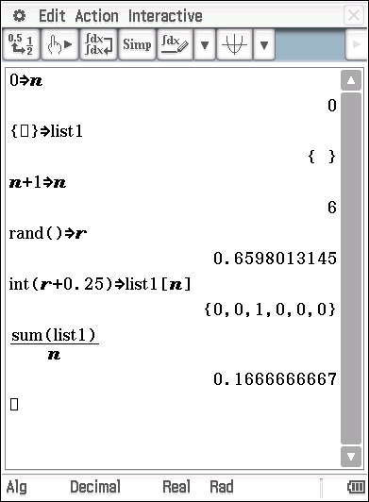

By adding the line in the routine we get a running average (or proportion) of the number of households that use WWGC mulch.

This screen shot shows the sample proportion when n = 6.

Perform your own simulation with and calculate the respective sample proportion,.

An example of one such simulated sample of 15 households is provided on the next page.

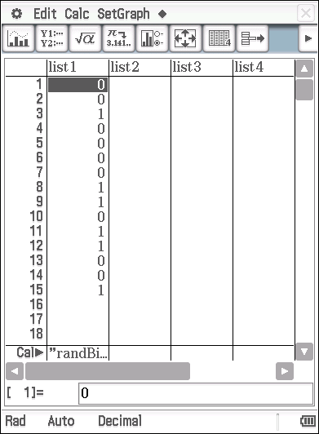
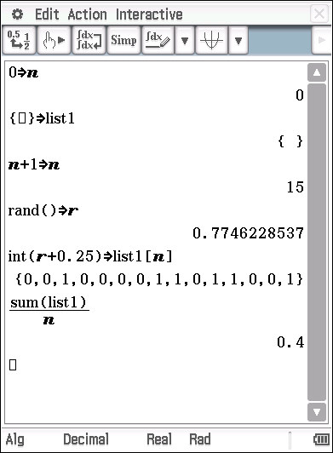

Task 2
Write a brief statement of interpretation of the information provided by the two screen shots above, in terms of the context of the situation.

The process used so far to generate random samples is rather tedious, especially if we wish to use sample sizes in the 100’s or 1000’s or if we wish to generate multiple samples of large .

Since the underlying distribution in this particular case is Binomial, we can use the randBin() command on the ClassPad. This will produce the number of “successes” for each of k samples of size n. For example, in the context of our WWGC mulch problem, randBin(10, 0.25, 15) will produce 15 numbers representing the number of households that used WWGC mulch for each of the 15 different samples of 10 households. A possible output screen shot is shown below.

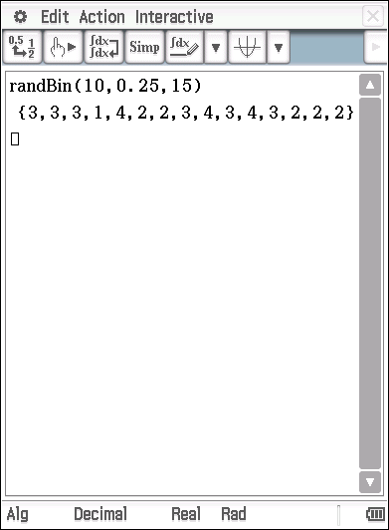

To produce the sample proportion () for each of the k samples, we simply need to divide by the sample size n.

For example, randBin(10, 0.25, 15)/10 will produce for 15 samples, each of size 10 where the underlying distribution is Binomial with an assumed population proportion of .
In the context of our WWGC problem, randBin(10, 0.25, 15)/10 will represent the simulated output of the proportion of households that used WWGC mulch, for each of 15 different samples of 10 households.

Try it. One possible result is shown below.

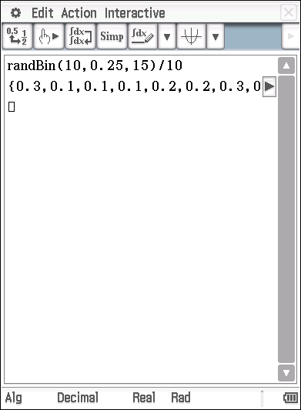

It is helpful to use a setup similar to our previous simulations for storing variables so we can easily vary
- store our data in lists
- graph the data and
- calculate simulated data statistics - such as the average of and the respective standard deviation.

For example, the illustration below shows the sample proportion from the simulation of 35 samples of 20 households.

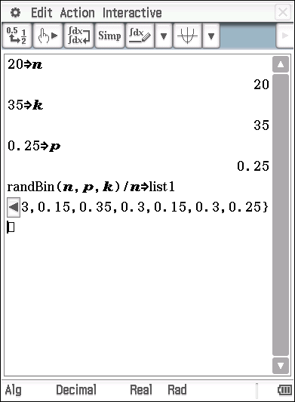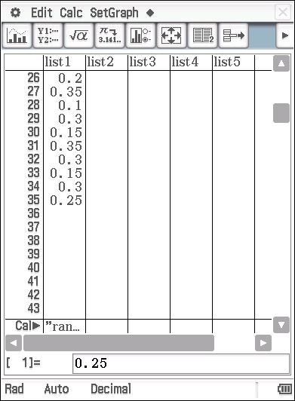
Main screen Statistics screen

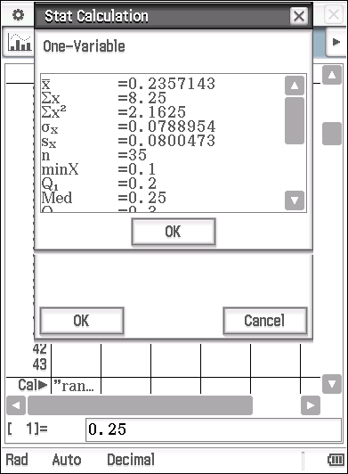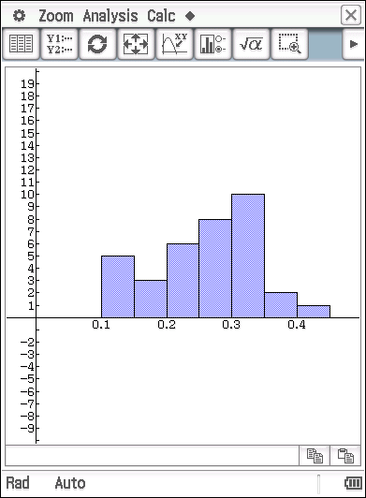
Statistics Calculation Histogram with HStep: 0.05

Note that the average of the sample proportion for the 35 samples of 20 households for this simulation is given by and the standard deviation of the 35 sample proportions is given by

Task 3
Perform suitable simulations of the proportion of households that use WWGC mulch.

- For samples of various sizes ( 10, 20, 30, 50, 100) generate simulations to illustrate the distributions of the sample proportion when , the number of samples, is
- 15.
- 100
Draw the respective graphs on the graph grids provided in the appendix (or insert suitable screen captures of the respective graphs from your calculator).

- State the mean and standard deviation of the distribution of the sample proportion for each of the samples of various sizes in the tables provided below.
Sample size ( ) | Mean of | Standard deviation of
10
20
30
50
100

Sample size ( ) | Mean of | Standard deviation of
10
20
30
50
100

- State any relevant conclusions that may be drawn from the results of the simulations and the respective graphs?

Task 4
Repeat the simulations from task 3 to illustrate possible distributions of sample proportions of households throughout WA that used mulch over the past twelve months (not just from WWGC).
Draw the respective graphs on the graph grids provided in the appendix (or insert suitable screen captures of the respective graphs from your calculator).

End of Questions

Appendix
Graph grids for use with Tasks 3 and 4.
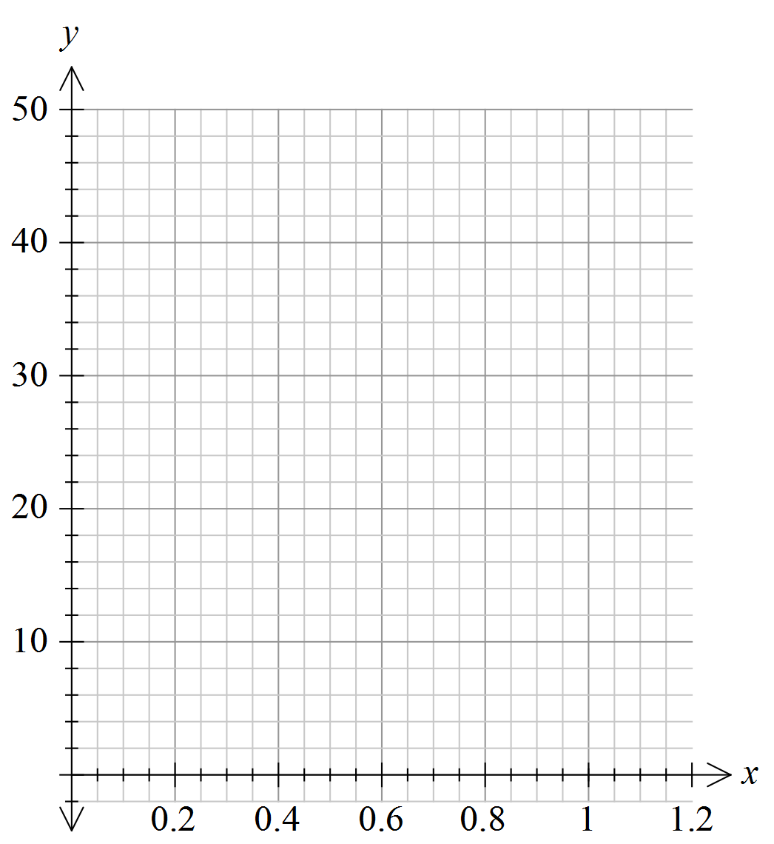


Graph grids for use with question one.


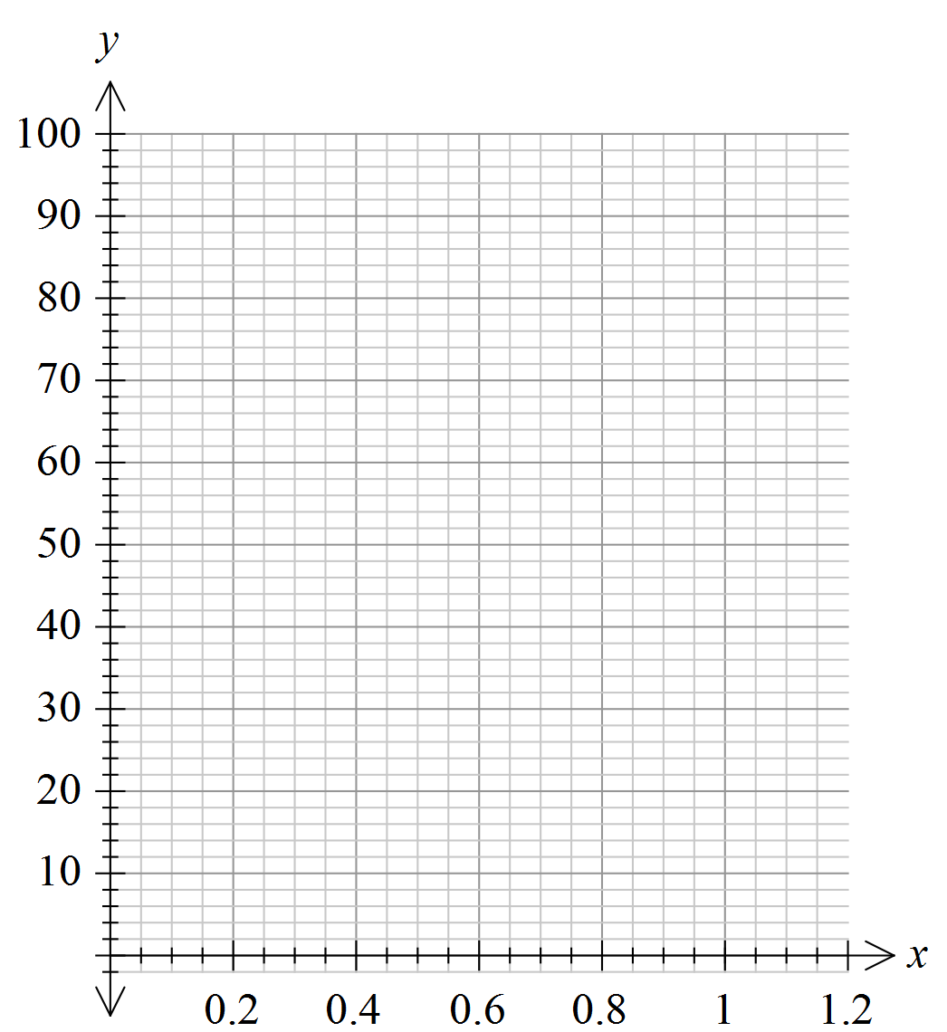

Extended investigation Part 2: In-class validation
NOTE: Calculator access assumed
Total: 26 marks

Question 1 (14 marks)
From the last census, it is known that the highest level of education of 27.5% of West Australians 15 years and older, was Year 11 or below.
- A random sample of 30 persons aged 15 years or older was undertaken, and asked the question,
“Is your highest level of education reached, at Year 12 or above?” Yes, or No.
The researchers record 1 for an answer of Yes and 0 for No.
Perform a suitable simulation of the survey on your CAS calculator and draw a graph to represent a likely result of the survey on the grid provided below.
Provide details of the simulation routine used. (4 marks)

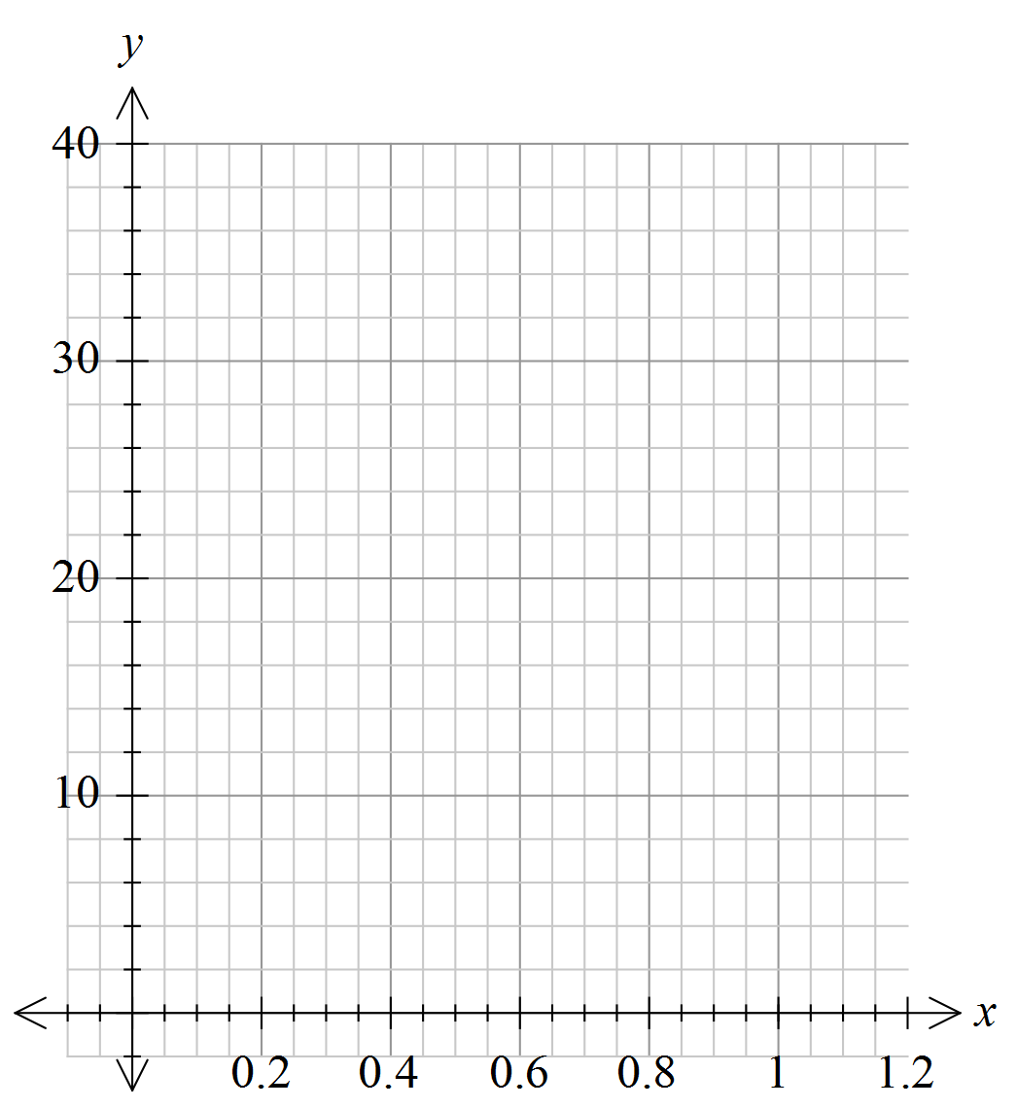
- Fifty randomly simulated samples were generated, each of size 30, and the results are summarised below.
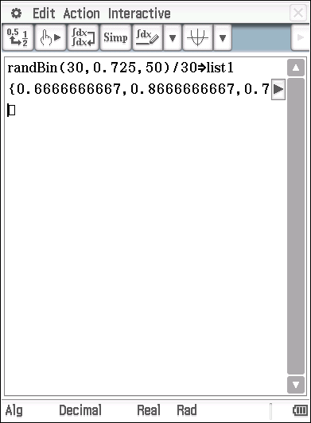
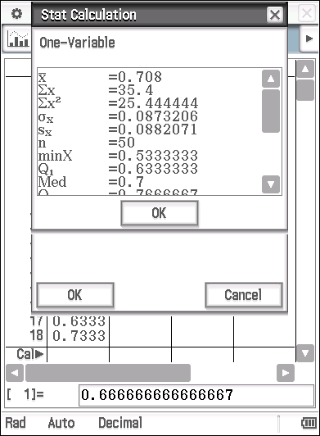
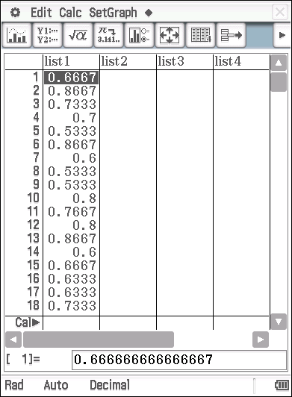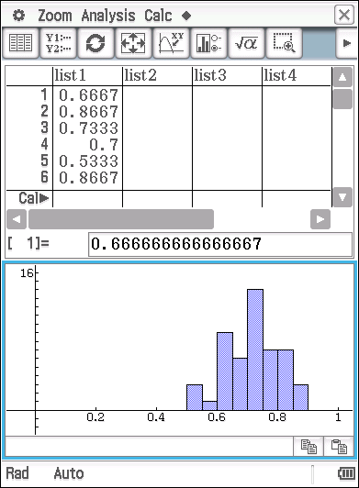

- What do the numbers in list1 represent? (2 marks)

- Give an interpretation for and . (2 marks)

- What is the graph a representation of? (2 marks)

- Using your CAS calculator, perform the same simulation as in part (b) but for 200 samples each of size 50.
Comment on the properties of the distribution of the sample proportions generated and compare it with the distribution provided in part (b). (4 marks)

Question 2 (6 marks)

From the last census we know that 40% of the adult population is in full-time employment. We would like to use this context to investigate how the sample proportion (of adults in full-time employment) changes as the number of samples (of a fixed size) changes.
(a) Use the randBin () command on your CAS calculator to perform appropriate simulations to complete the table provided below, given that each sample is of size 25. (3 marks)

Number of samples | Mean of | Standard deviation of
10
20
50
100
250

- Describe your findings and state any conjectures that you think may be plausible.
(3 marks)

Question 3 (6 marks)
A new type of drug is designed to help people with type II diabetes. Suppose that patients to test the new drug were selected from a large group that was normally distributed with a mean ‘blood sugar’ reading of 6.0 mmol/L and a standard deviation of 0.6.
To make a random selection of 18 patients from the group so that every person in the group has an equal chance of being selected, we would use randNorm(0.6,6.0,18)

If we run such a simulation a possible result is shown below.
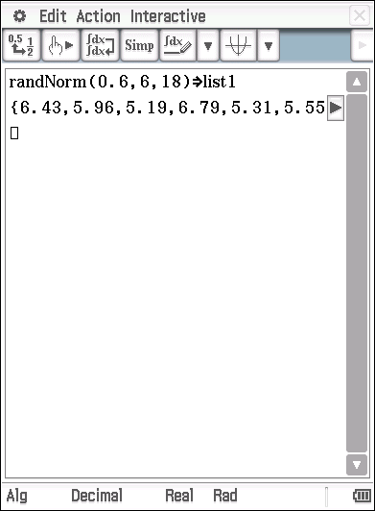
Note: Here the basic format has been set to Fix 2.
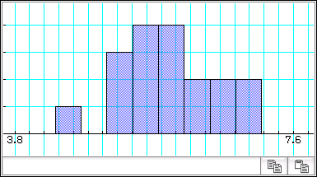
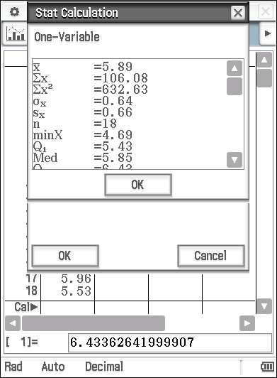
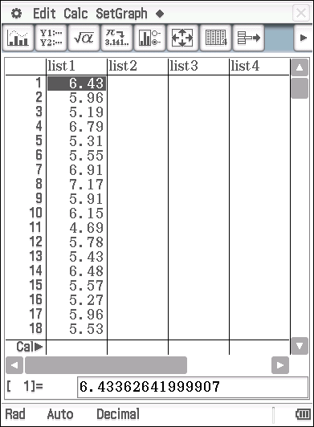

- Provide statements by way of interpretation of these results, referring to population and sample parameter statistics as appropriate. (4 marks)

- Assume the ‘normal’ range for blood sugar readings is 2.5 - 5.4. If represents the sample proportion of those that have a blood sugar reading above the ‘normal’ range, determine for the provided sample. (2 marks)

End of questions
Extended investigation Part 1: Preparation activity

Solutions

Task 1
Solution
The data in list1 simulates the number of households in a random sample of 10, that used WWGC mulch. In this particular sample, it is 2 out of 10. That is, the proportion of households that used WWGC mulch, as indicated by the given sample, is

Task 2
Solution
In this particular randomly generated sample of 15 households, 6 out of the 15 households used WWGC mulch. This gives

Task 3 (a)(i)
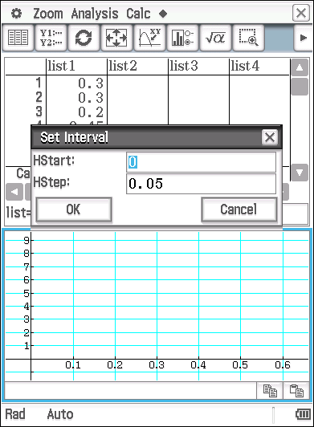
Solution: Note that the values generated for will vary. The graphs below are examples only. To aid comparisons, the horizontal axis has been fixed to a max of 0.65 and the HStep set to 0.05.
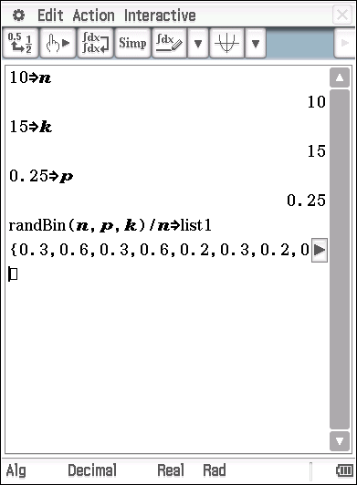

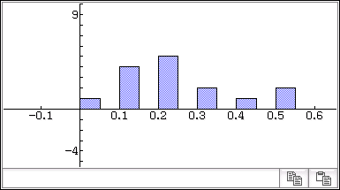

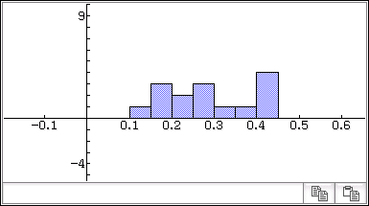

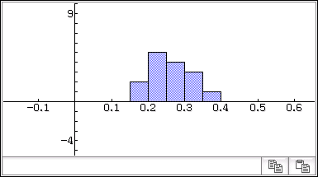

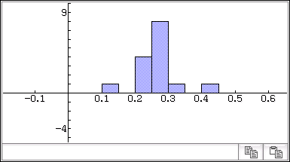

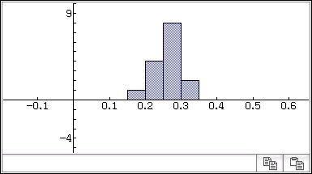

Task 3 (a)(ii)

Solution: Note that the values generated for will vary. The graphs below are examples only. To aid comparisons, the horizontal axis has been fixed to a max of 0.65 and the HStep set to 0.05.
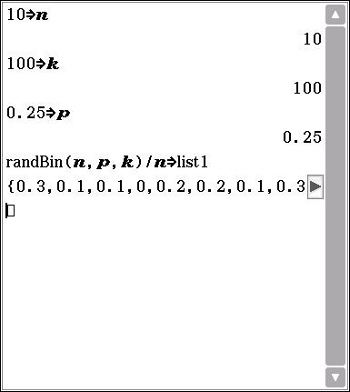

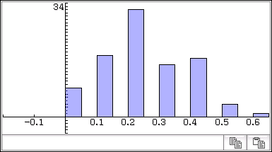

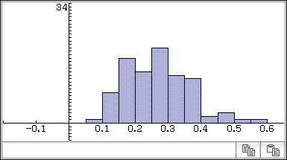

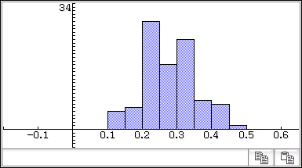

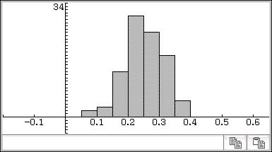

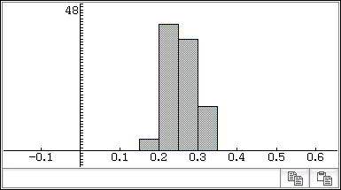

Task 3 (b)
Solution
Note: Your numbers will vary from these illustrative examples but the general patterns should hold.
(i)

Sample size ( ) | Mean of | Standard deviation of
10 | 0.227 | 0.1436
20 | 0.263 | 0.1024
30 | 0.253 | 0.0514
50 | 0.257 | 0.0579
100 | 0.251 | 0.0406

(ii)

Sample size ( ) | Mean of | Standard deviation of
10 | 0.23 | 0.1362
20 | 0.2425 | 0.0973
30 | 0.270 | 0.0766
50 | 0.2476 | 0.0612
100 | 0.2557 | 0.0377

Task 3 (c)
Solution
From the tables in task 3(b) it can be seen that the mean of fluctuates about 0.25 (as expected) irrespective of the sample size or of the number of simulations that are performed with the same sample size.
The standard deviation of gets smaller as the sample size increases. This is more evident as the number of simulations performed is increased (ie. it is more evident for than for although the trend is still evident for ).
This may be seen in the graphical illustrations of the distributions of as well - see distributions in Task 3(a) above.

Task 4
Solution
This requires the repeating of the simulations and graphical displays etc. as per Task 3 using instead of 0.25. A few illustrative screen shots are shown below.
,
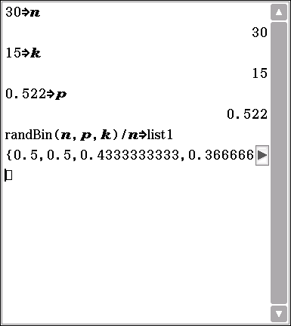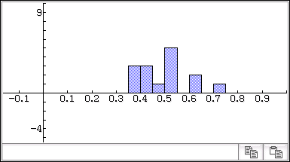

,
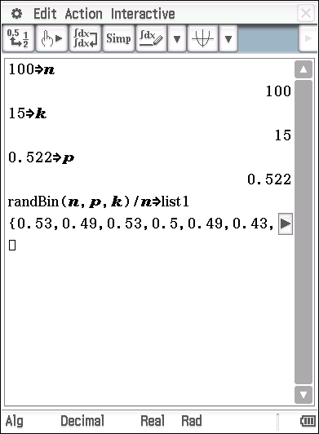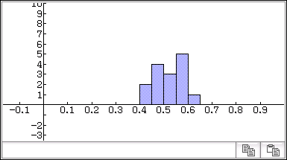

,
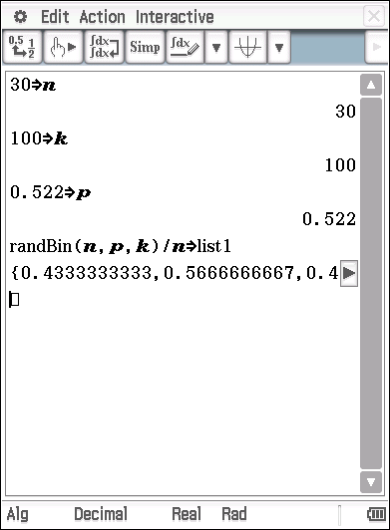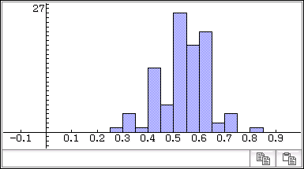

,
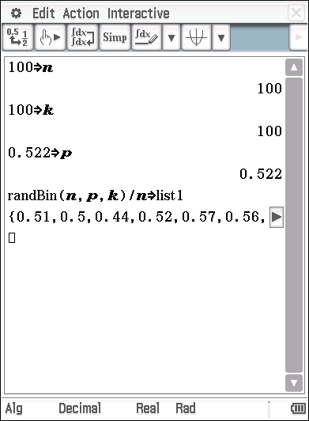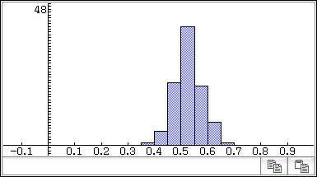

Conclusion/observations similar to those from task 3(c) are also appropriate here.
In addition, it is clear that the distributions of are normally distributed about the assumed population proportion of and that the standard deviation of is reduced as both the sample size and the number of samples increase.

Sample proportion distributions

Extended investigation Part 2: In-class validation

Solutions and marking key

Question 1 (a)
Solution
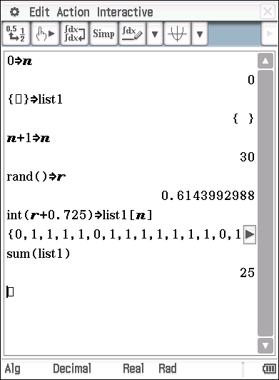
, so a possible simulation would be

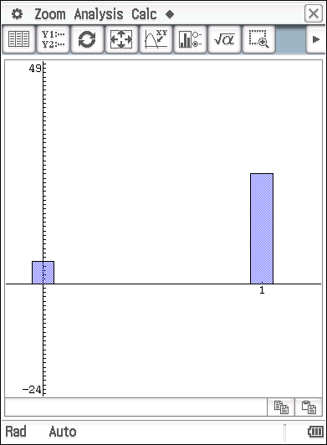

A possible graph could be

(any proportional split that is close this, is acceptable)

Mathematical behaviours | Marks
- uses  - provides an acceptable simulation routine  - draws a suitable graph illustrating the number of 0’s and 1’s  - the sum of the 0’s and 1’s adds to 30 and (roughly) the appropriate proportions | 1  1  1  1

Question 1 (b)
Solution
- Since the random Binomial numbers generated are divided by 30 and each of the 50 samples are of size 30, the numbers in list1 represent the proportion of those that answered ‘yes’ to the question posed in part (a) for each sample.
- is the mean of the 50 sample proportions (), each having been calculated from the 50 samples of size 30. represents the standard deviation of the 50 sample proportions ()
- The graph illustrates the distribution of the sample proportions for this particular simulation. It represents the number of samples (out of 50) where the proportion of those sampled was within a particular interval. For example, in 14 of the 50 samples (of size 30) the proportion who answered yes (and had an education level of Year 12 or above) was between 0.7 and 0.75

Mathematical behaviours | Marks
(i)  - indicates that they are sample proportions  - relates these back to the question in part (a)  (ii)  - identifies as the mean of  - identifies as the standard deviation of  (iii)  - indicates that the graph represents the distribution of the sample proportions  - interprets the scale in relation to the context | 1  1  1  1  1  1

Question 1 (c)
Solution
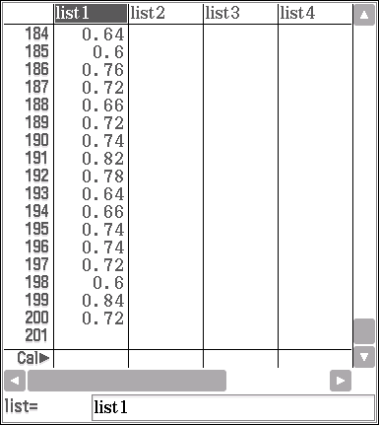
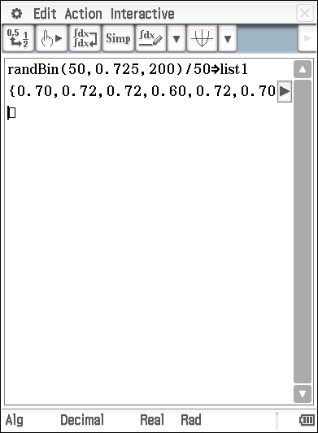

Note that list1 now contains 200 ’s.
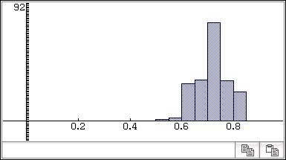

The graph is centered about 0.71 as indicated by the mean of the ’s below.
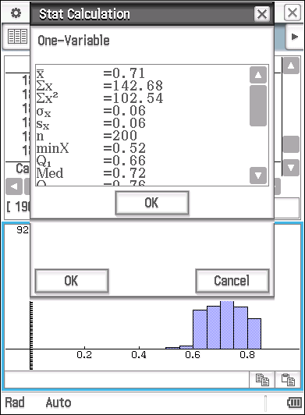
- This distribution (of ) is clearly normal with a mean close to and a small standard deviation (of 0.06). This is reflected in the bunched up nature of the distribution as shown by the histogram and is smaller than the standard deviation of associated with the simulation in part (b) [ which was 0.087.]

Mathematical behaviours | Marks
- identifies the mean of as close to  - determines the standard deviation of  - identifies this to be smaller than the standard deviation of associated with the simulation in part (b)  - a meaningful comment about the impact of increasing sample size or increasing the number of sample simulations. | 1  1  1  1

Question 2
Solution
- From the census we know that where represents the proportion of adults in full -time employment.

Using randBin(25,0.4, )/25 to generate distributions of the table below may be completed as requested. These are illustrative answers only as each simulation will be different.
Number of samples () | Mean of | Standard deviation of
10 | 0.33 | 0.09
20 | 0.42 | 0.12
50 | 0.37 | 0.09
100 | 0.41 | 0.11
250 | 0.40 | 0.1

- The mean of seems to fluctuate about 0.4 (irrespective of the number of samples) which is as expected since
There does not seem to be any observable pattern to the standard deviation of from this particular set of simulations.
Plausible conjecture: the sample means () of samples of a fixed size vary about the population proportion or something along these lines
Mathematical behaviours | Marks
(a)  - identifies  - determines plausible figures for the mean of  - determines plausible figures for the standard deviation of  (b)  - provides a reasonable interpretation associated with the mean of  - provides a reasonable interpretation of the figures associated with the standard deviation of  - provides a plausible conjecture | 1  1  1  1  1  1

`

Question 3(a)
Solution
The simulation generates, in this case, the ‘blood sugar’ readings of a randomly selected sample of 18 patients from a normally distributed population with a mean blood sugar reading of 6 mmol/L and standard deviation of 0.6.
The generated sample has a mean of 5.89 and a standard deviation of 0.64
The ‘blood sugar’ readings of the 18 patients are provided in list1.
The graph shows the distribution of these 18 blood sugar readings. It does not look particularly symmetric, but could be ‘normal’, considering that the sample size is quite small.
Mathematical behaviours | Marks
- identifies the simulation  - states the mean and standard deviation  - accurately describes what the numbers in list1 are  - provided an appropriate interpretation of the graph | 1  1  1  1

Question 3(b)
Solution
There are 4 numbers in list1 that are within the ‘normal range’. Hence 14 out of the 18 are above the normal range. This means that (to two decimal places)
Mathematical behaviours | Marks
- uses list1 to determine the number above (or below) the normal range  - correctly calculates | 1  1

TASK 17

Confidence intervals for proportions

In-Class Investigation

Unit 4

Topic 4.3: Interval estimates of proportion

Course-related information

The concepts and skills included in this investigation relate to the following dot points within the WA Mathematics Methods syllabus:

Confidence intervals for proportions
4.3.7 examine the concept of an interval estimate for a parameter associated with a random variable
4.3.8 use the approximate confidence interval $\left(\hat{p}-z\sqrt{\left(\frac{\hat{p}\left(1-\hat{p}\right)}{n}\right)}, \hat{p}+z\sqrt{\left(\frac{\hat{p}\left(1-\hat{p}\right)}{n}\right)}\right)$ as an interval estimate for $p$, where $z$ is the appropriate quantile for the standard normal distribution
4.3.9 define the approximate margin of error $E=z\sqrt{\frac{\hat{p}\left(1-\hat{p}\right)}{n}}$ and understand the trade-off between margin of error and level of confidence
4.3.10 use simulation to illustrate variations in confidence intervals between samples and to show that most, but not all, confidence intervals contain $p$

Background information

Students should have reviewed their knowledge of the content of the topic, Continuous random variables and the normal distribution. Students should have had at least an introduction to the concept of ‘confidence intervals’ for the population proportion and be aware of appropriate simulation routines to generate simulated sample proportion data for various distributions.

Task conditions

This task consists of an in-class investigation for which students may need 45 – 55 minutes to complete. Students do need to be familiar with the use of CAS technology to work with the normal distribution and to find confidence intervals for the population proportion. It is expected that they will have access to such technology during the investigation.

Confidence intervals for proportions

In-class investigation Total marks: 34

Suppose that we want to know what proportion of the population of Perth have a smart phone?

As we do not know the value of the population proportion,, that have a smart phone, we are interested in obtaining an estimate of . A single observation of can be used to provide a point estimate of the unknown population proportion,. The sample proportion is an estimate of the population proportion,.

We are also interested in quantifying the uncertainty of using as an estimate of . Although the underlying distribution would be binomial, as the sample size,, increases, the distribution of the sample proportions will approach that of a normal distribution, with mean, and standard deviation, .

Question 1 (17 marks)

A survey of 500 Perth residents indicates that 340 had smart phones.

- Determine the sample proportion,, of the Perth residents surveyed that own a smart phone. (1)

Suppose that multiple simulations of the survey were to be performed. Each simulation of the survey will result in a different value for.
- State an estimate for the mean and standard deviation of the sample proportions,. (3)

Assuming that is large enough, the distribution of the sample proportions,, may be considered to be normally distributed.

- If ten random samples of 500 Perth residents are simulated, in how many of the samples would you expect 350 or more residents to have a smart phone?
Justify your estimate. (4)

- In order to explain the estimate from part (c) to her superior, a researcher performed some simulations of the situation, the results of which are shown below.
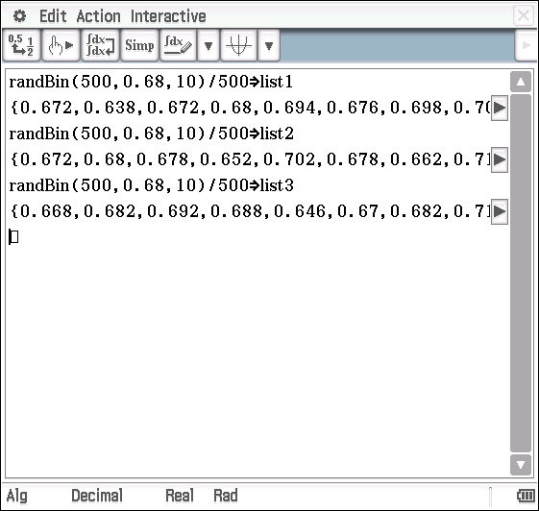
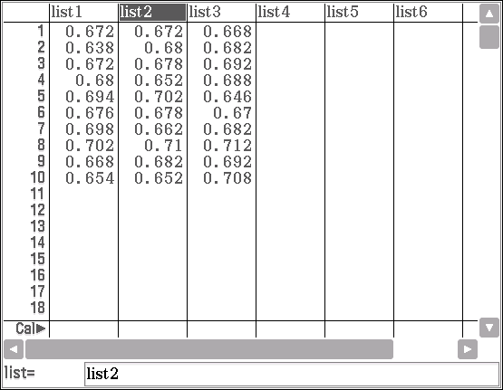
Provide an interpretation of these results, indicating whether they support the result from part (c) or not. (5)

- A smart phone distribution company employed a researcher and requested that she use the survey information available to provide them with a range of the number of smart phones per 1000 Perth residents, of which they could be confident. Provide a sample answer that you suggest she might give. (4)

Question 2 (9 marks)

The value of the sample proportion,, is going to change from sample to sample. Often, it is more appropriate to use an interval estimate which we can be reasonably be sure contains the population parameter,.
Hence, we often use the approximate confidence interval $\left(\hat{p}-z\sqrt{\left(\frac{\hat{p}\left(1-\hat{p}\right)}{n}\right)}, \hat{p}+z\sqrt{\left(\frac{\hat{p}\left(1-\hat{p}\right)}{n}\right)}\right)$ as an interval estimate for , where is the appropriate quantile for the standard normal distribution.

In WA, a survey of attitudes towards the introduction of a refund for recycling drink containers (cans and glass and plastic bottles) was undertaken. A random sample of 1000 people was chosen and each person was asked to answer the question:

‘Do you think the government should introduce a refund on returned drink containers (cans and bottles)?’

A total of 640 people answered ‘yes’ to the question.
- Based on the results of the survey, determine the 99% confidence interval for the proportion of the population of W.A. who agree with the introduction of the recycling refund. Provide an interpretative statement as to what the interval means. (3)

A researcher conducted simulations of the survey to model likely responses. The results of the simulation are shown below.
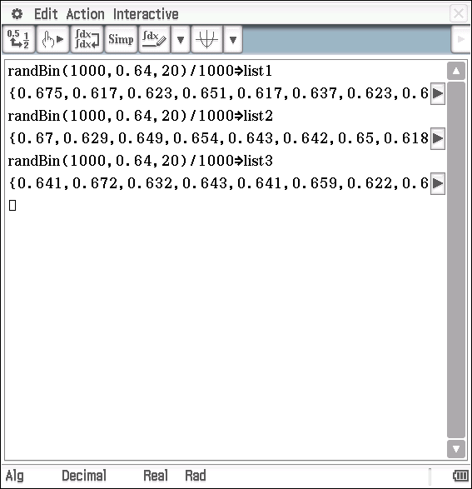
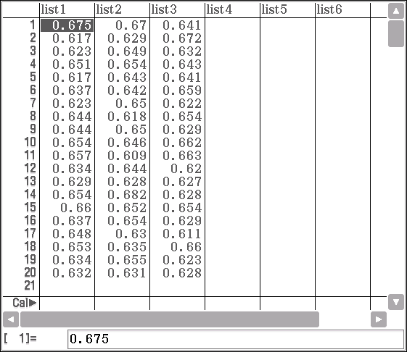

- Do any of the sample proportions generated by the simulation fall outside the confidence interval you found in part (a). Provide a possible interpretation of why this would be the case. (2)

- Determine the 95% confidence interval for the proportion of the population of W.A. that agree with the introduction of the recycling refund. Do any of the sample proportions generated by the simulation fall outside the 95% confidence interval you found in part (b)? Provide a possible interpretation of why this would be the case.
(4)

Question 3 (8 marks)

A random sample of 620 golfers found that 200 of them were left-handed.
The 95% confidence interval of the proportion of left-handed golfers may be found as follows, using the statistics App of a ClassPad calculator.
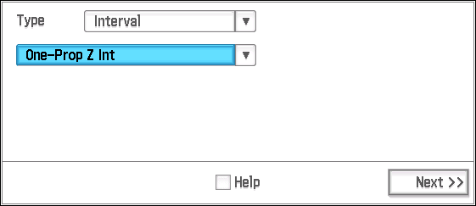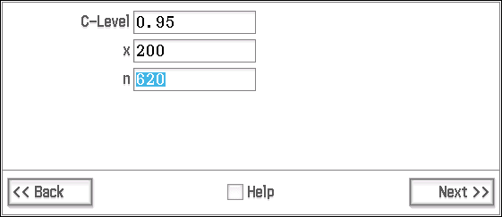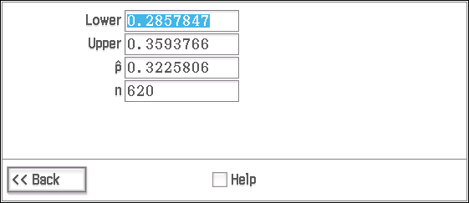
Asked to provide an interpretation of this result, a company marketing employee states that based on the survey the proportion of golfers that are left-handed may be estimated to 32.26% and that the probability =0.95.
- Write a brief comment, explaining whether the company employee has provided a valid and comprehensive interpretation. (4)

The margin of error () is described as the distance between a sample estimate and the endpoints of a confidence interval. is given by the rule , where is the appropriate quantile for the standard normal distribution.

- Determine the margins of error for 95% and 90% confidence intervals for the proportion of left-handed golfers. (2)

- Explain briefly how the margin of error varies as the confidence interval changes. (2)

End of questions

Confidence intervals for proportions

In-class investigation
Solutions and marking key

Question 1(a)
Solution
Mathematical behaviours | Marks
- correctly determines the sample proportion, | 1

Question 1(b)
Solution
The mean of =0.68, and using the same ,
the standard deviation of
Mathematical behaviours | Marks
- correctly states the mean of  - applies correctly  - states the correct standard deviation | 1  1  1

Question 1(c)
Solution
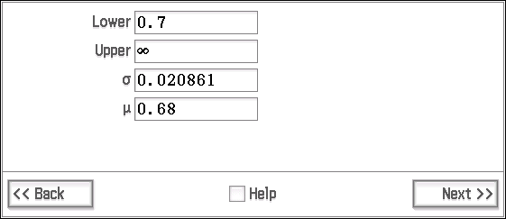
Assuming the sample proportions are normally distributed with a mean of 0.68 and standard deviation of 0.020861 (as found in part (b)) then we may calculate the probability that a randomly selected using the ‘Normal CD’ function on the calculator.

Hence, the probability that a particular will be greater than 0.7 (i.e. that more than 350 out 500 residents will have a smart phone) is 0.1688.

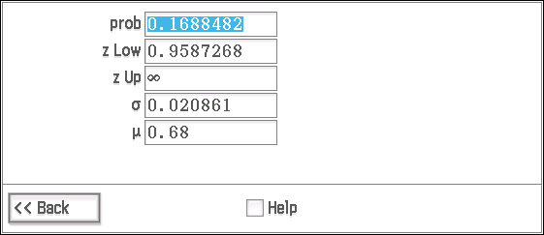
Multiplying by 10, since there are 10 samples in the simulation, we get 1.688.

Of course there will not be 1.688 samples with more than 350 residents having smart phones. We would expect 1 or 2 (most likely 2) samples to have 350 or more residents with smart phones.
Mathematical behaviours | Marks
- applies the normal distribution with correct mean and standard deviation  - calculates  - multiplies by 10 to get the number of samples  - interprets the meaning of the answer correctly | 1  1  1  1

Question 1(d)
Solution
The information provided shows the simulation of 10 samples from a binomial distribution with a population proportion of 0.68 and a sample size of 500.

The simulation is repeated 3 times and the values of the sample proportions,, are displayed in 3 separate lists.

From list 1, it can be seen that there is only one sample proportion which is greater than 0.7 (i.e. there is only one of the 10 samples that has more than 350 residents with a smart phone). This is sample 8 with . In list 2, there are two (samples 5 and 8) and in list 3 there are also two (samples 8 and 10).

Hence these results support the theoretically calculated result from part (c) which also suggested that 1 or 2 of the 10 samples would have 350 or more Perth residents with a smart phone.
Mathematical behaviours | Marks
- correctly identifies the information is from a binomial distribution  - identifies the numbers in the lists as sample proportions  - identifies the number of sample proportions > 0.7 in each list  - interprets the meaning of the in terms of the context of the situation  - makes the appropriate connection with part (c). | 1  1  1  1  1

Question 1(e)
Solution
The researcher could calculate various confidence intervals and use them to provide the range requested to varying degrees of confidence.
The 90% confidence interval for could be calculated as follows:
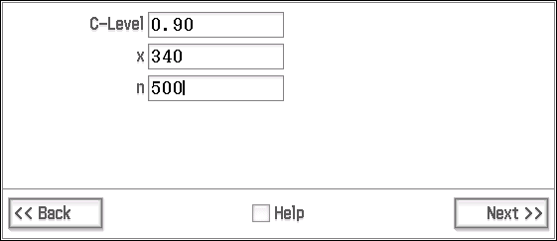
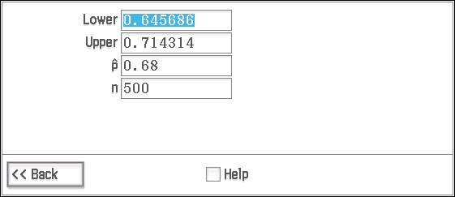
From these results, the researcher could suggest that the number of residents with a smart phone would be between 645 and 714 (per 1000 Perth residents) and she could say this with 90% confidence.
If the company wants a higher degree of confidence, the researcher could suggest that between 639 and 721 (per 1000 Perth residents) have a smart phone, and she could say this with a 95% degree of confidence. The researcher could also point out that the higher the level of confidence that they require, the larger the interval range will be.
Mathematical behaviours | Marks
- correctly calculates the 90% confidence interval  - correctly calculates the 95% confidence interval  - provides suitable numbers by way of intervals  - correctly interprets the meaning of the numbers (in terms of confidence) | 1  1  1  1

Question 2(a)
Solution
Based on the survey, ,
99% confidence interval: (0.6009, 0.6791)
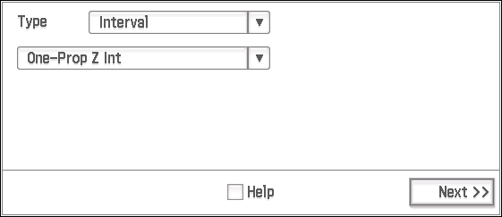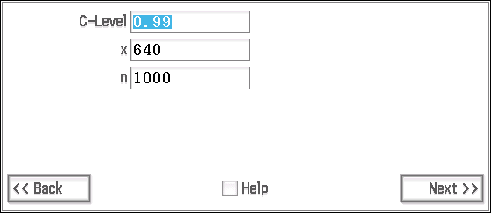
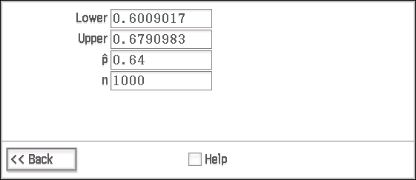
Hence, we can be 99% confident that out of every 1000 people between 601 and 679 people agree with the recycling refund.

Mathematical behaviours | Marks
- correctly determines the 99% confidence interval for  (either using the One-Prop z-interval on a CAS calculator  or using $\left(\hat{p}-z\sqrt{\left(\frac{\hat{p}\left(1-\hat{p}\right)}{n}\right)}, \hat{p}+z\sqrt{\left(\frac{\hat{p}\left(1-\hat{p}\right)}{n}\right)}\right)$  - provides an interpretive statement as to the meaning of the interval, in the context of the situation | 2  1

Question 2(b)
Solution
No, none of the in the data lists provided fall outside the 99% confidence interval.
This is because the 99% confidence interval is large enough to include, all the ’s that are approximately, standard deviations, either side of . This is most unlikely.
Mathematical behaviours | Marks
- correctly says, No.  - provides an acceptable interpretation | 1  1

Question 2(c)
Solution
95% confidence interval: (0.6102, 0.6698)
4 out of the 60 sample proportions are outside the C.I., namely – below, 0.609 (list 2 number 11) and above, 0.675 (list 1 number 1), 0.682 (list 2 number 14), 0.672 (list 3 number 2).
We would expect some of the ’s to be outside the CI (it is not a 100% CI) but 4 out of 60 is actually on the high side for a 95% CI.
Mathematical behaviours | Marks
- determine the 95% CI correctly  - identifies 4 of ’s as outside the CI  - provide a suitable interpretative statement | 2  1  1

Question 3(a)
Solution
From the survey, the proportion of left handed golfers () may be estimated to be or 32.26% as provided in the statement by the marketing employee.

However, it is not appropriate to say that . This statement is .meaningless, as either does or does not lie within the confidence interval.
A better interpretation would be to have said that approximately 95% of such intervals will contain the population proportion,. The CI will be different for each as can be seen from the formula for the calculation of C.I.’s $\left(\hat{p}-z\sqrt{\left(\frac{\hat{p}\left(1-\hat{p}\right)}{n}\right)}, \hat{p}+z\sqrt{\left(\frac{\hat{p}\left(1-\hat{p}\right)}{n}\right)}\right)$
Mathematical behaviours | Marks
- indicates that the estimate for , based on the survey results, is correct  - identifies the probability statement as inappropriate  - provides an appropriate statement for the interpretation of the confidence interval  - indicates that there is a confidence interval dependent on each | 1  1  1  1

Question 3(b)
Solution
changed to 0.03680 from 0.03697
Mathematical behaviours | Marks
- calculates each margin of error correctly | 1+1

Question 3(c)
Solution
As the degree of confidence for a confidence interval increases, from 90% to 95% for example, the margin of error decreases. This is because an increase in the degree of confidence increases the length of the confidence interval and so the chance of being outside the confidence interval decreases.
Mathematical behaviours | Marks
- provides a good, clear statement  - provides any plausible statement (1 only) | 2  (1)

TASK 18

Investigative Questions

Unit 4

Topic 4.2: Interval estimates of proportion

Course-related information

The concepts and skills included in this investigation relate to the following dot points within the WA Mathematics Methods syllabus.

4.3.1 examine the concept of a random sample
4.3.2 discuss sources of bias in samples, and procedures to ensure randomness
4.3.4 examine the concept of the sample proportion $\hat{p}$ as a random variable whose value varies between samples, and the formulas for the mean $p$ and standard deviation $\sqrt{\frac{p\left(1-p\right)}{n}}$ of the sample proportion $\hat{p}$
4.3.7 examine the concept of an interval estimate for a parameter associated with a random variable
4.3.8 use the approximate confidence interval $\left(\hat{p}-z\sqrt{\left(\frac{\hat{p}\left(1-\hat{p}\right)}{n}\right)}, \hat{p}+z\sqrt{\left(\frac{\hat{p}\left(1-\hat{p}\right)}{n}\right)}\right)$ as an interval estimate for $p$, where $z$ is the appropriate quantile for the standard normal distribution
4.3.9 define the approximate margin of error $E=z\sqrt{\frac{\hat{p}\left(1-\hat{p}\right)}{n}}$ and understand the trade-off between margin of error and level of confidence
The ability to choose and use appropriate technology to enhance and extend concept development is also incorporated within some of the items.

Background Information
Each of the questions provided can stand alone and may be incorporated into different tasks (exams or tests).It is not intended that they form part of the same assessment. Students should have covered the syllabus concepts listed above before attempting these tasks.
Task conditions
Each question should be undertaken under test conditions and should be completed within 15-20 minutes. Use of a graphical/CAS calculator is assumed.

Question 1 (16 marks)

Proportions in a population are said to follow a normal distribution if the following conditions are met:
and
Researchers are interested in finding the proportion of children aged 8 to 18 years old who have a particular medical condition.
562 children throughout Australia were selected as a random sample.
It was found that 10 children in the sample had this medical condition.
a) What would you suggest as a population mean and population standard deviation for the probability that a child has the condition?
Justify any assumptions you have made.
Note: You are asked for the Probability not the Number (5)

b) In a school with 1065 children between the ages of 8 and 18, how many would we expect to have the condition?
Give your answer at the 90% confidence level.
Justify your answer. (4)

c) The Department of Public Health wish to conduct a survey to verify the above results.
What sample size should they select to ensure the population mean for the probability that a child has the condition lies within a 3% margin of error with 95% confidence?
Justify any assumptions you have made. (7)

Question 2 (12 marks)

Candidate was one of two candidates in a local by-election#.

On the day of the election, an exit poll* was conducted by members of his election team.
They decided to record the results of the male and female votes separately.

From a random sample of 319 females, 187 said that they had voted for Candidate .
From a random sample of 261 males, 118 said that they had voted for Candidate .

(a) Assuming that the answers given were truthful, construct an approximate
95% confidence interval for

(i) the proportion of females who voted for Candidate .

(ii) the proportion of males who voted for Candidate .

Justify any assumptions you have made. (6 marks)

(b) State, with a reason, whether females were more likely than males to vote for Candidate . (2 marks)

(c) At the close of voting the supporters, based on their exit poll results, believed that Candidate had won the by-election.

Comment, with justifications, on their belief. (4 marks)

# an election to select elected offices that have become vacant between
general elections

* an opinion poll of people leaving a polling station, asking how they voted.

Investigative Questions
Solutions and marking key
Question 1 (a)
Solution
As we only have information for a sample rather than the population, we will use the sample mean and the sample standard deviation as point estimates for the population parameters.
and so the conditions are met.
The estimate of the probability that a child has the condition would be the proportion of children in the sample with the condition.
P(child has the condition) = = = 0.01780.
We will now use the sample proportion as the population proportion. Standard deviation of the sample, (i.e. standard error)
= = = 0.005577
Hence we will use as the population parameters: the mean, = 0.01780 and
the standard deviation, = 0.005577
Mathematical Behaviours | Marks
- demonstrates that the conditions are met.  - links the estimate of the probability to the proportion of children in the sample with the condition  - determines correctly  - determines the population parameters correctly | 1  1  1  1+1

Question 1 (b)
Solution
The proportion of children with the condition (using the estimated values above) at the 90% confidence level would be
0.008626 0.02697
Number of children:
9.2 28.7
Hence we would expect between 10 and 28 children to have the condition.
Mathematical Behaviours | Marks
- uses estimated values (and states as such)  - uses the appropriate z-value in the interval calculation  - calculates the proportion interval correctly  - provides the interval for the number of children with the condition | 1  1  1  1

Question 1 (c)
Solution
c) Note: Margin of error and confidence interval are distinct ideas.
The 95% confidence interval would give us the range of results expected in 95 out of 100 surveys. It arises from probability considerations as we are surveying a sample and not the population.
The margin of error includes Coverage Error, Measurement Error, and Non-Response Error. These are errors that arise in the actual surveying process.
At the 95% confidence level
(i) If we use 0.01780 as an estimate for as in part (a) then,
Margin of error =
= 0.0178
= 74.63
(ii) If we use = 0.5 as an estimate for which will give the maximum sample size,
= 0.5
= 1067.111… 1068
Mathematical Behaviours | Marks
- an explanation of the concepts of confidence interval and margin of error and the differences/inter-relations between them  - use of from part (a) or uses =0.5 with appropriate justification  - applies margin of error formula  - calculates the correct sample size and rounds up | 2  1+1  1  1+1

Question 2 (a)
Solution
Assumptions:
There is randomness in selecting participants in the exit poll 95% confidence interval:
i) females
ii) males
Mathematical Behaviours | Marks
- states the assumption  - acknowledges the randomness of an exit poll  - calculates the confidence interval for females  - calculates the confidence interval for males | 1  1  2  2

Question 2 (b)
Solution
Lower bound for females > Upper bound for males
Hence it is fair to say that females are more likely than males to vote for Candidate
Mathematical Behaviours | Marks
- indicates lower bound for females is greater than upper bound for males  - concludes females are more likely than males to vote for Candidate | 1  1

Question 2 (c)
Solution
As there are two candidates, Candidate needs greater than 50% of the vote to win the by-election.
Lower bound of 95% confidence interval for female voters > 0.5, so a majority of females will vote for Candidate .
The proportion of males in the total number of voters could be well over 50%, therefore there is no guarantee that more than half of all of the voters will vote for Candidate .
We do not know the overall percentages of males and females voting in the by-election.
Conclusion: The belief of Candidate ’s supporters is unjustified.
Answer must include at least three reasonable justifications.
Mathematical Behaviours | Marks
- makes the correct conclusion  - provides at least 3 reasonable justifications (1 each) | 1  3

